**Home** – Go to column A

**Ctrl+home** – Go to A1 cell

**Tab** – Move to right cell

**Shift+Tab** – Move to left cell

**Serial number**

To increment data. Enter 1st two data and then drag. If we enter only 1st data and then drag, it will enter same number to place where we dragged

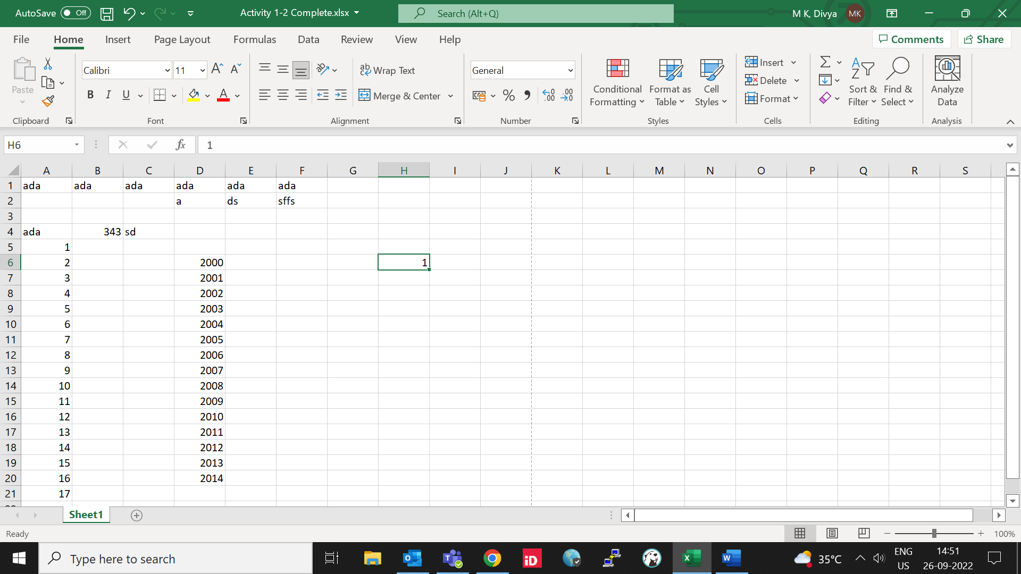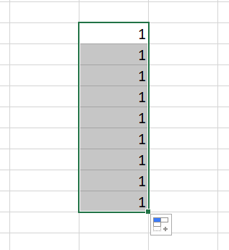

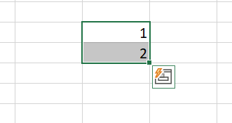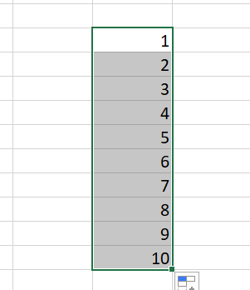

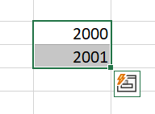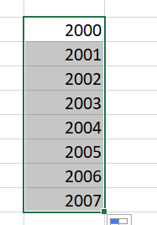

Same is used for all process.

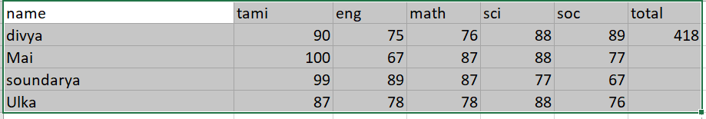

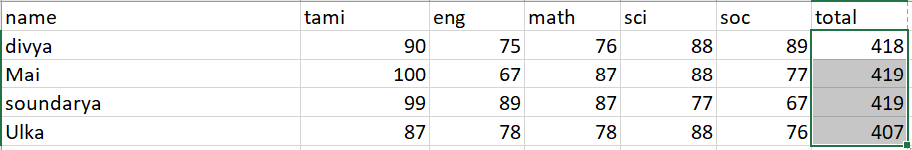

**Fill option:**

Used for above process. We can set step process.

**Flash fill:**

It’ll automatically fill from given data

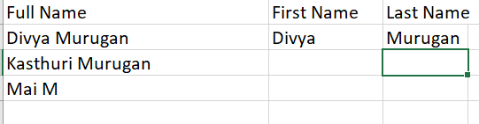

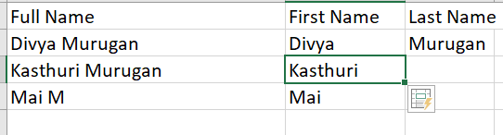

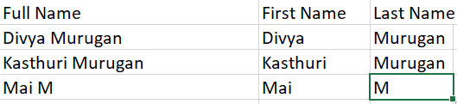

**Ctrl+z – Undo**

**Ctrl+Y – Redo**

**INSERT, DELETE & FORMAT ROWS & COLUMNS**

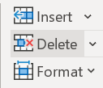

Format will change size of rows or columns

**Merger**



Merge no of rows or columns

**Hyperlink**

Shortcut – Ctrl+k

Alt+enter – to move alignment from right to left or viceversa

**Wrap text** 

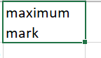

**Find & Replace –** ctrl+F

**Go to –** ctrl+G

**Spell check**

Review tab 🡪 spelling or F7

**FUNCTIONS**

**= X>Y** TRUE OR FALSE



In place of X and Y we can use cell position like B2,C4,C6 etc…

Like that we can use

**= A+B+C+D….**

**=SUM(RANGE OF VALUES)**

Eg: =SUM(B2:E2)

**=X+Y/Z**

**MATHEMATICAL OPERATIONS (follows BEDMAS RULE)**

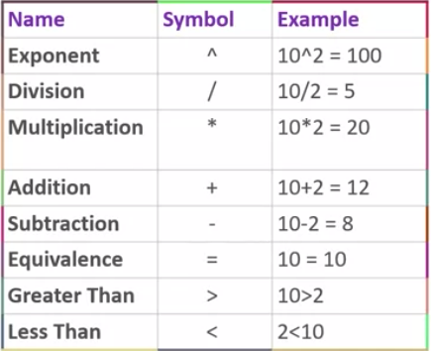

**RANGE NAMES**

* Can start with letter, underscore, backslash
* Any letter or number after first letter
* No space allowed
* Manually define in formula tab 🡪 define name

**SPECIALIZED FUNCTIONS:**

* Sumif–sum for given condition

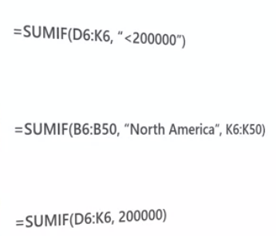

(syntax: sumif(range, criteria, sum_range))

Range – range in which criteria need to check

Sum_range – range in which sum need to perform

* Averageif
* Countif
* **IFS FUNCTION – (For more than one criteria)**
* Sumifs
* Averageifs
* countifs

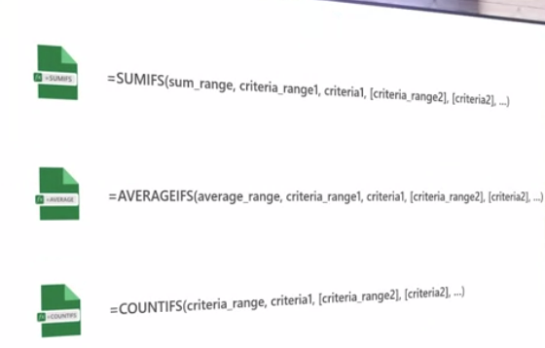

For more functions go to formula tab 🡪insert function. We can also see syntax of respective functions.

**TEXT FUNCTIONS**

**LEFT & RIGHT FUNCTIONS**

=left(text,num) from leftt it will display that many numbers. If num not given by default it will take only one letter from left. Similary, for right.

**MID** =mid(text,start_num,num)

**LEN** =len(text)

**TRIM –** remove space in front of text [=trim(text)]

**PROPER –** even if text is not in format like upper and lower cases shuffled it will make everything to same case

**UPPER & LOWER –** for upper & lower cases

**TEXTJOIN –** textjoin **(**delimiter, TRUE/FALSE ,text1,text2….)

TRUE/FALSE to ignore empty space. true will ignore &false won’t

If delimiter not given, it will join without any space.

**LOGICAL FUNCTIONS & OPERATORS**

Logical functions results in true/false

AND

OR

IF

IFS

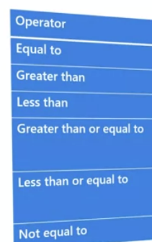

**TABLE**

To create table drag portion need to make table and insert tab 🡪table

Auto expansion:

To insert new row or column…enter value in that new row or column and hit tab…new row or column will created.

**SUBTOTAL FUNCTION**

**=**subtotal(fun_num,ref1,…)

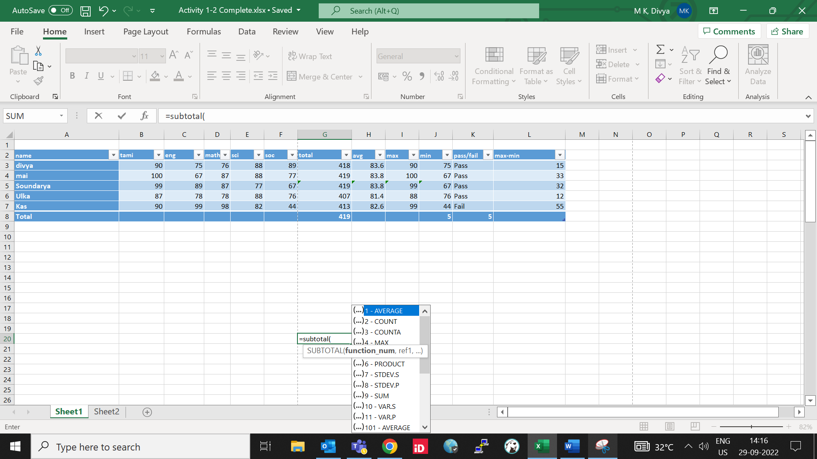

**DCOUNT** =dcount(database,field,criteria)

To select all fields in full database....table_name[#All]

**DATABASE FUNCTIONS**

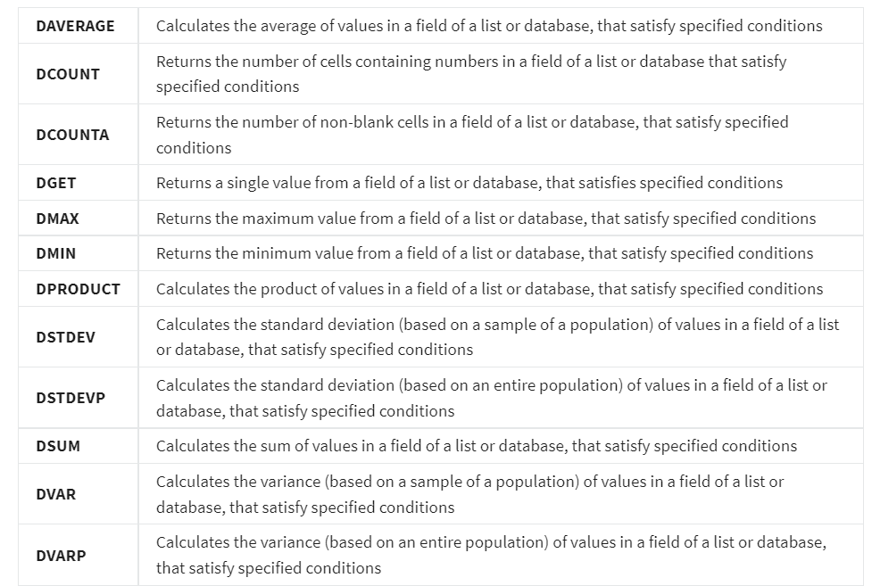

**TO RENAME SHEET**

Home🡪format🡪rename sheet

**TO ADD TWO NUMBERS FROM TWO DIFFERENT SHEETS**

=sum(sheet3!cell_no+sheet2!cell_no)

**FREEZE**

Freeze cells or top row using freeze option in view tab.

**SPLIT**

We can split sheet into four parts and view corresponding values nearer. View🡪split

**TO OPEN SAME CONTENT IN ANOTHER WORKBOOK**

Instead of copy paste. View🡪new window

**Introduction to DAX**

When you create a Pivot Table report using PowerPivot, you are usually joining several tables together to analyze the data in all the tables and generate results from all the information. When you link tables together in Pivots, you create what is called a Data Model and when you are working in PowerPivot you are working directly in this Data Model. Creating formulas in the Data Model, requires you to use a specialized language and syntax. The language you use to create formulas in a Data Model Is DAX.

A significant difference between a DAX Function and an Excel function is that DAX Functions will always refer to a complete row, column, or table. On the other hand, Excel Functions refer to a single cell or range of cells. This allows for DAX Functions to return an entire table of results.

In Pivots, you can use advanced formulas called Measures. They can only be created after a PivotTable or PivotChart has been added to a workbook. They will provide you with results dynamically and are dependent upon any filters that have been applied to the PivotTable or PivotChart. For example, if you wanted to find the number of products that a single warehouse has that are worth over $500, you could use a measure to find that information. Measures are often created using DAX.

Variables can also be used in a formula created with DAX which increases the flexibility of the formula. By declaring a Variable first, the Variable name can be inserted in more complex expressions to make them more readable. When a Variable is being defined, the definition begins with an equals sign followed by “var”. The Variable name is then inserted followed by an expression. The syntax is as follows:

VAR <variable name> = <expression>.

The results of the expression are stored as a Named Variable. Once the Named Variable is declared, it can be used in many other expressions.

While there are lots of DAX Functions that you can choose from, each function will be classified under one of the following categories:

Data and Time functions: Functions of this type are used to manipulate date and time values. As such, they are like the data and time functions that can be used in Excel.

**Filter functions:** These functions are used to manipulate data and filter it dynamically.

**Information functions**: This type of function is used to scan the values inside a cell range and match them against an expected data type.

**Logical functions:** Typically, these functions are used to validate expressions and values, and then work with other data that is based upon the evaluation.

**Math and Trigonometric functions**: Functions of this type are used to perform mathematical calculations.

**Statistical functions:** These functions are used to generate statistical data such as minimum and maximum values, as well as averages.

**Time Intelligence functions**: This type of function is used to manipulate data using time periods. It can be used to compare data of one time-period against another.

Aggregate Functions are also more powerful in DAX. The standard Aggregate Functions in Excel can be used in Excel spreadsheets, Pivot Tables, and PowerPivot Tables. DAX Aggregate Functions address many of the shortcomings of standard functions by providing a means to aggregate data across columns and tables instead of just cells and groups of cells.

Below you will see the types of Aggregate Functions that are available and what they do:

**AVERAGE**

This function returns an average of all the numerical data in a column

**AVERAGEA**

This function returns an average of all the numerical data in a column, but it can also work with non-numerical data as well.

**COUNT**

This function returns a count of the number of cells in a column that contain numerical data.

**COUNTA**

This function returns a count of the number of cells in a column that contain any data (numerical or otherwise).

**MIN**

This function returns the smallest number value that was found in a column.

**MINX**

Returns the smallest value from a set of expressions evaluated over a table.

**MAX**

This function returns the largest number value that was found in a column.

**MAXX**

Returns the largest value from a set of expressions evaluated over a table.

**SUM**

This function will add and display the total of all numbers in a column.

In addition to these functions, there are additional functions that are available in the DAX language only. These functions include the following.

**AVERAGEX**

Averages a set of expressions evaluated over a table.

**COUNTAX**

Counts a set of expressions evaluated over a table.

**COUNTX**

Counts the total number of rows in a table.

**COUNTROWS**

Counts the number of rows returned from a nested table function, such as filter function.

**SUMX**

Returns the sum of a set of expressions evaluated over a table.

**TO ADD COMMENT TO ANY CELL OT GROUP OF CELL:**

Select review tab🡪new comment

Or right click and new comment

Or ctrl+shift+F2

**TO ADD NOTE TO CELL**

Select review tab🡪notes

**TO SET BACKGROUND IMAGE**

Page layout🡪background